A.Y. 2019-2020:
TLC Head: Mr.K. Seshacharyulu ( HOD, Mechanical Engg.)
TLC Members: 1) Dr. P. Gayatri Pavani (Assoc.Prof., Head dept. of Physics )
2) Mr.Poorna Chandra Reddy (Asst Prof., dept. of ECE)

VISION AND MISSION OF TLC:

VISION
To Enhance Quality of Teaching Learning Processes and Activities in All the Departments of Engineering and Technology
MISSION
1. To promote various Teaching Pedagogies to Faculty
2. To Facilitate Training in OBE
3. To Develop Learning Resources

Activities of TLC in A Y 2019-20:-
During Saturday afternoons TLC encourages the faculty to share their learnings from different training programmes.
TLC has organized many faculty development programmes/workshops/conferences. 70 faculty from all departments participated in ICTIEE-2020.

S.No | Name of Training Program | Duration | Resource Person
1. | Three day workshop on outcome based teaching, learning and assessment strategies | 24-05-2019 to 27-05-2019 | Prof.B.V.Appa Rao, (Retd), TLC, NITW.
2. | Presentation on "Use of Technology to be smart at work place " | 14-06-2019 | Mr.SharathVedhula, R&DEngineer, SPHN
3. | Two day internal conference on" effective teaching practices " | 01-07-2019 and 02-07-2019 | Faculty members of Sphoorthy engineering college
4. | Three day workshop on "Outcome based Teaching, Learning and Assessment Strategies" | 04-07-2019 to 06-07-2019 | Prof. B.V.Appa Rao( Retd) , TLS, NITW
5. | Awareness Program on "course outcomes, mapping with PO's" | 14-09-2019 | Dr M.V.S. Ramprasad,PRINCIPAL and Mr.Ram Mohan Rao, IQAC
6. | Assessment Evaluation and Analysis of test item | 02-11-2019 | Dr. P. Gayatri Pavani,  Assoc Prof., Head, dept. of Physics
7. | Workshop on "Google ICT tools for effective teaching and learning process" | 14-07-1019 | Mr. V. Poornachandar Reddy,Asst Prof, ECE Dept
8. | Presentation on "Orientation for writing research proposal & articles " | 28-12-2019 | Dr. N. Suresh, HOD,ECE Dept
9. | Workshop on "21 st Century Pedogogy " | 18-01-2020 | Mrs. S Sirishaprasad, Asst Prof, H&S Dept
10. | Brainstorming session on "ICT Tools for teaching and learning" | 01-02-2020 | Faculty members, SPHN
11. | Hands-on- webinar 0n " Explore Google forms" | 03-06-2020 to 05-06-2020 | Mr. V.Poorna chandar Reddy, Asst Prof, ECE Dept

- 70 faculty members from Sphoorthy Enginnering College participated in ICTIEE 2020 organized by IUCEE and Anurag Group of Institutions, Hyderabad( 06-01-2020 to 08-01-2020)

- Mr.Ram Mohan Rao, Assoc Prof., CSE was awarded IUCEE transformational award in the category of " leadership of Teaching and Learning Center” at ICTIEE-2020.

- Examples of innovative pedagogical practices among faculty

1. Think, pair and share
2. Use of Plickers
3. Use of Google class room
4. Use of Google forms, Google quiz and Google word building
5. Interactive teaching models
6. Jig saw teaching methodology
7. Problem based learning
8. Project based Learning
9. Teaching by students

TLC PHOTOS
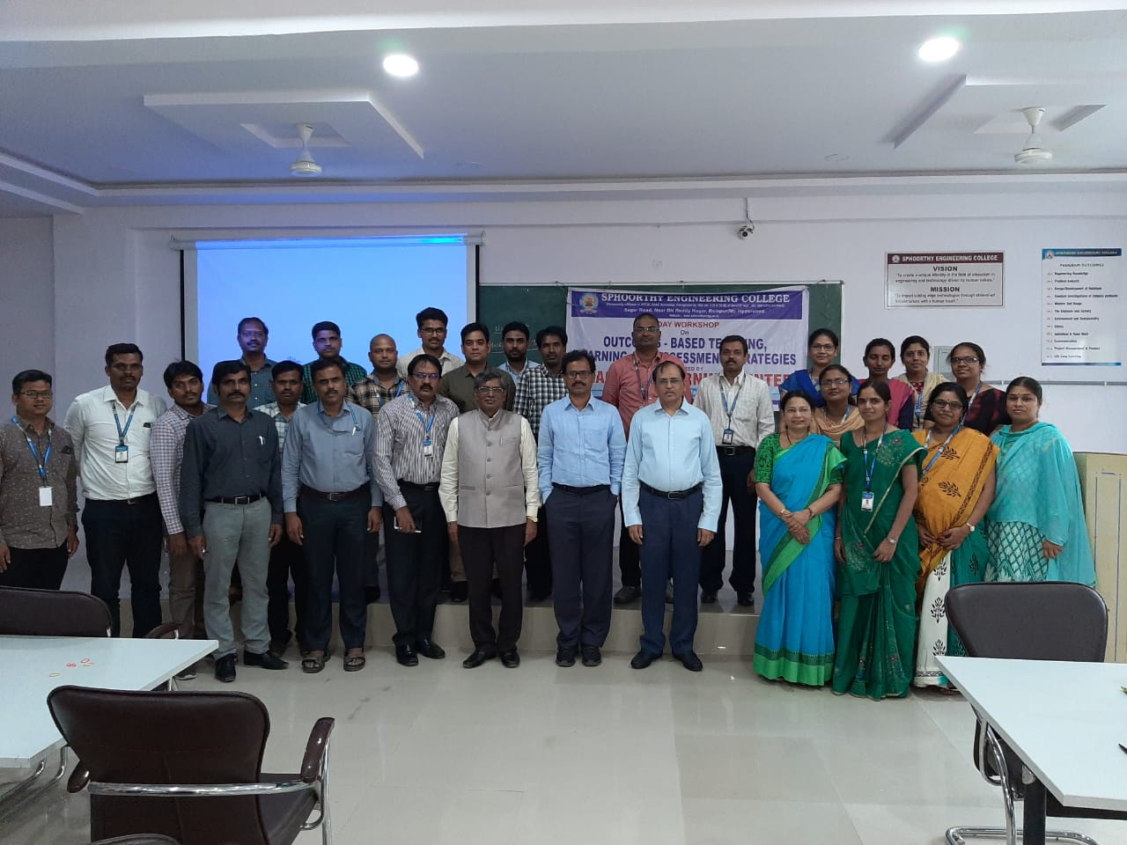

2

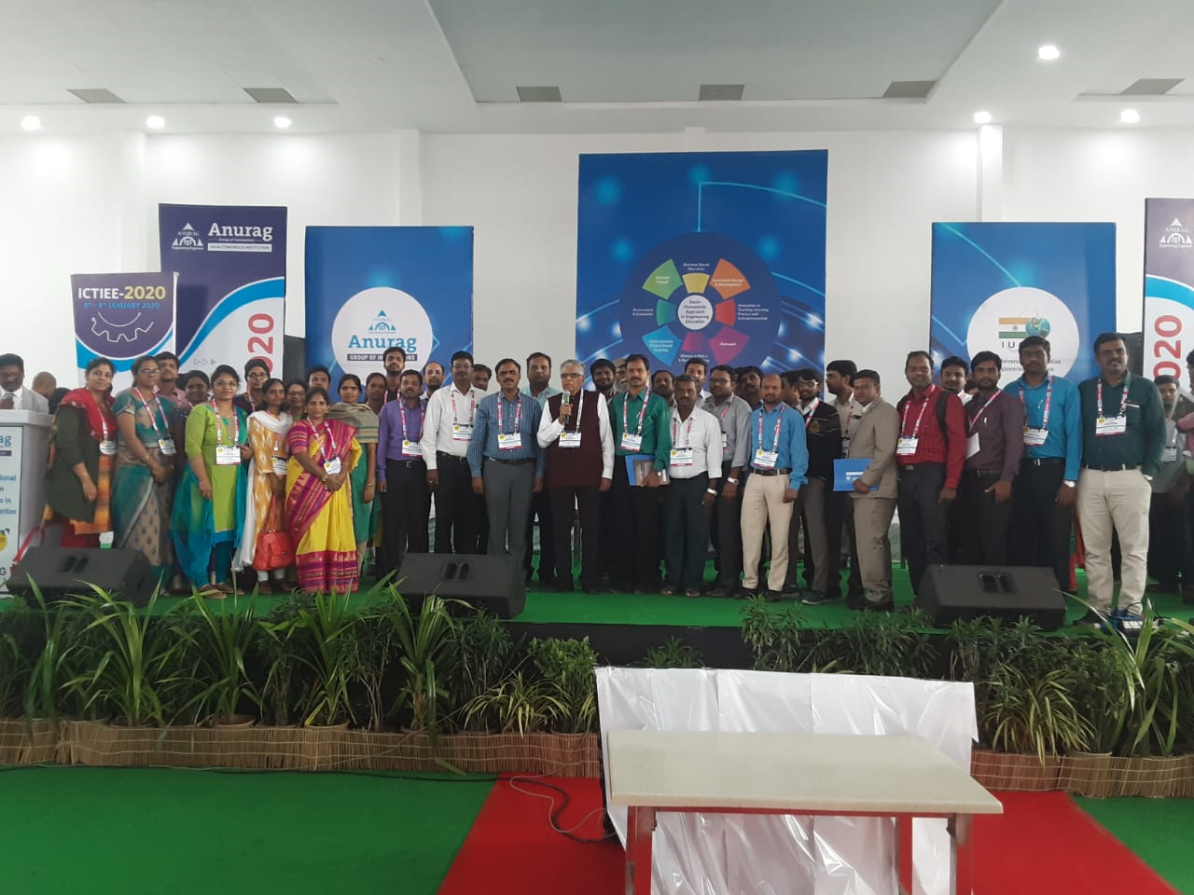
SPHN Faculty members at ICTIEE-2020

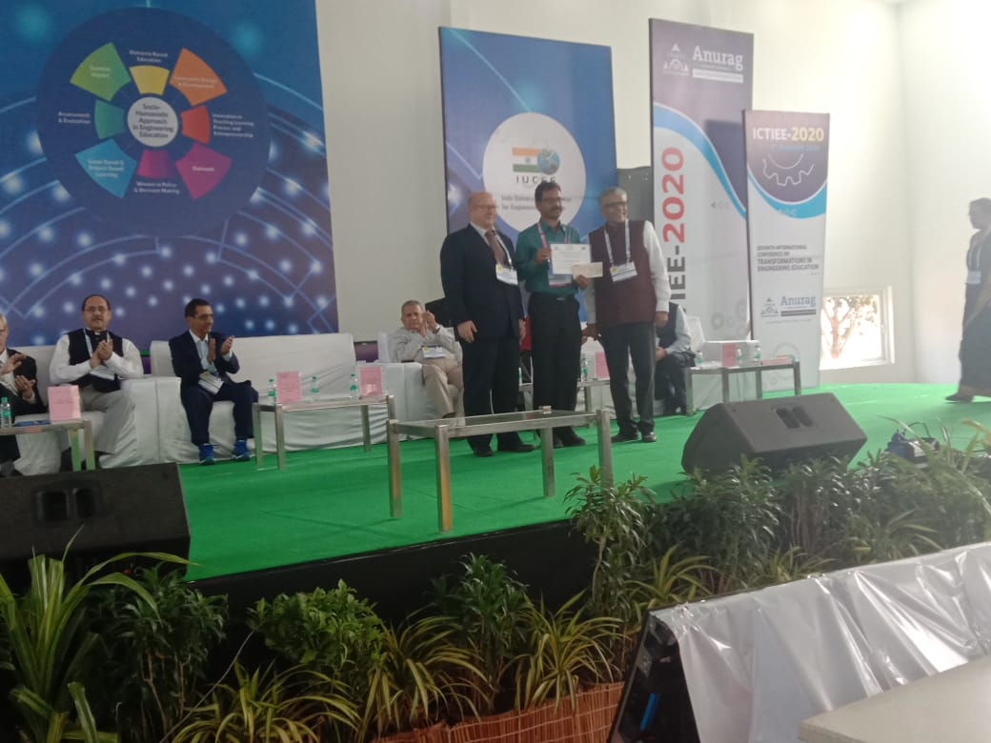Sri S Jagan Mohan Reddy, secretary sir receiving Best Institutional leader award for at ICTIEE-2020

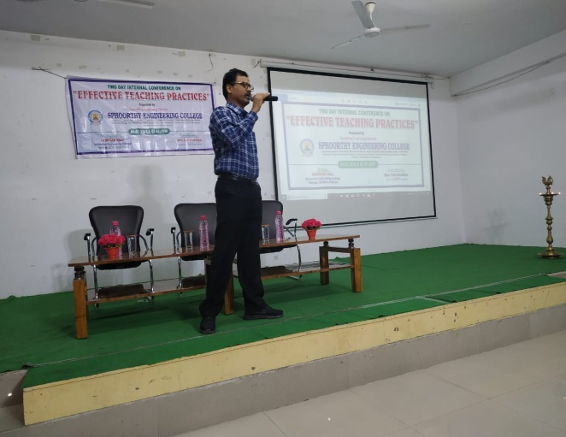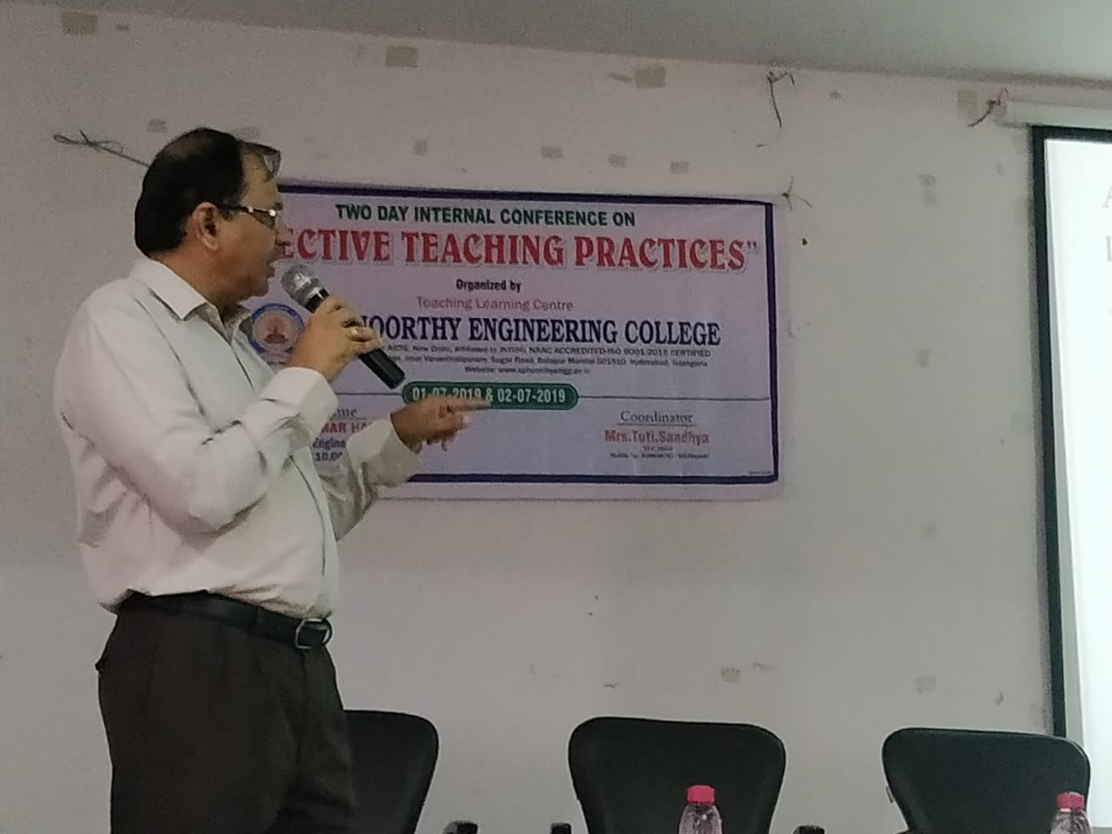
Secretary sir and Principal sir at Two day internal conference on effective teaching practices

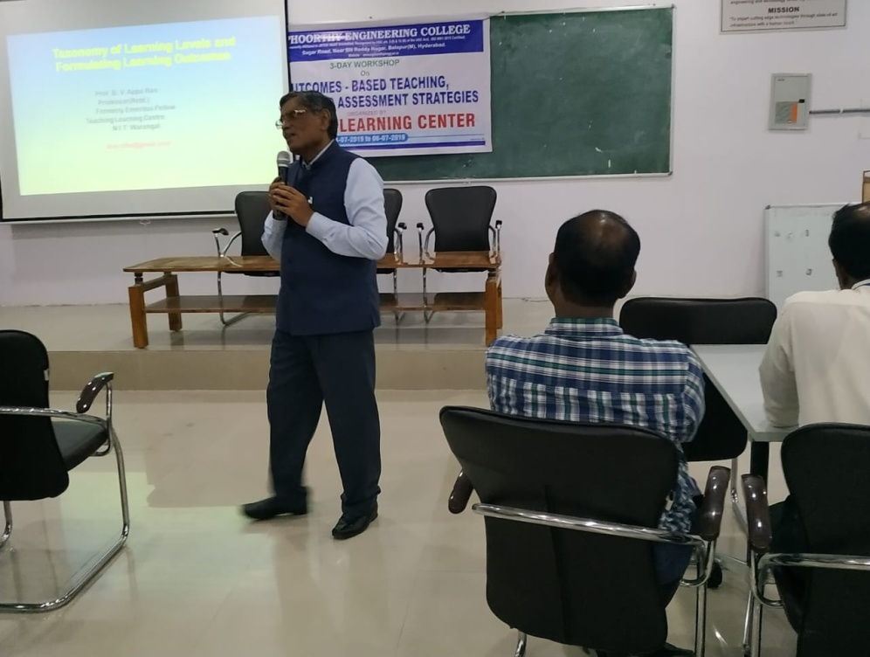
Outcome based Teaching, Learning and Assessment Strategies by Prof.B.V.Appa Rao ( Retd), NITW.

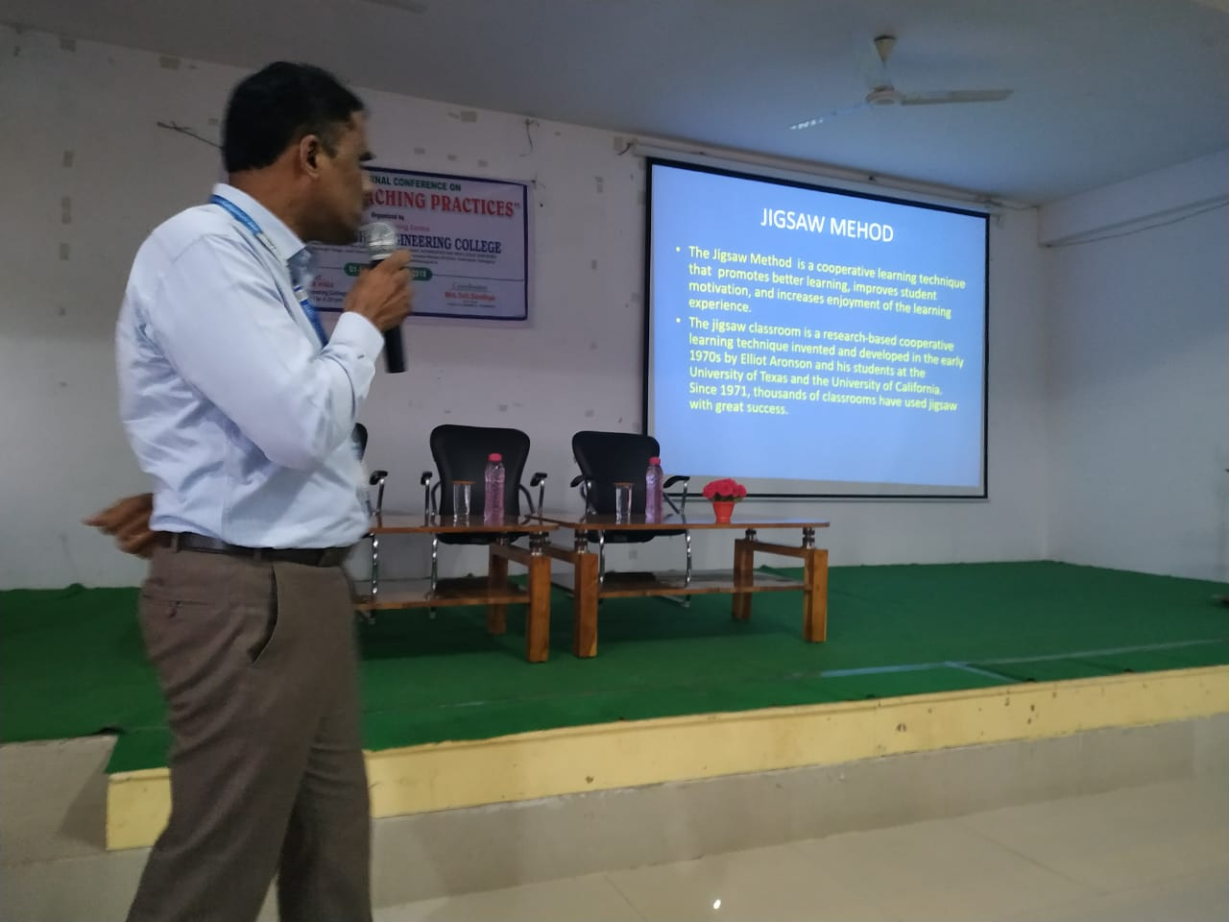
Mr. K Seshacharyulu, HOD-MECH delevering presentation on on effective teaching practices

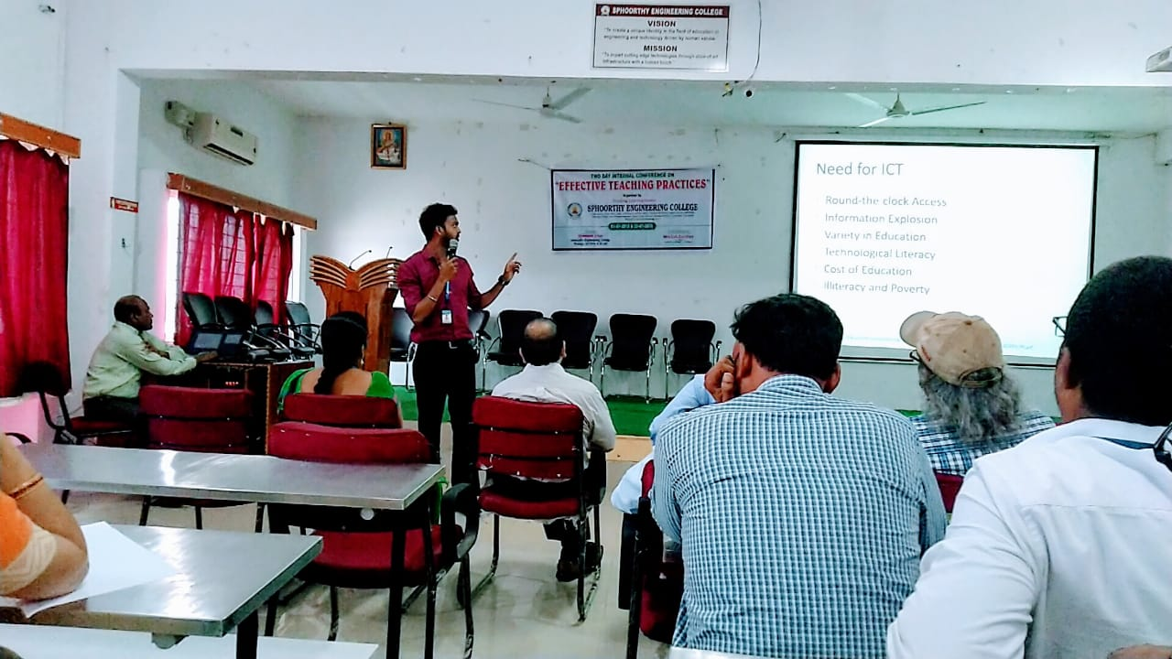
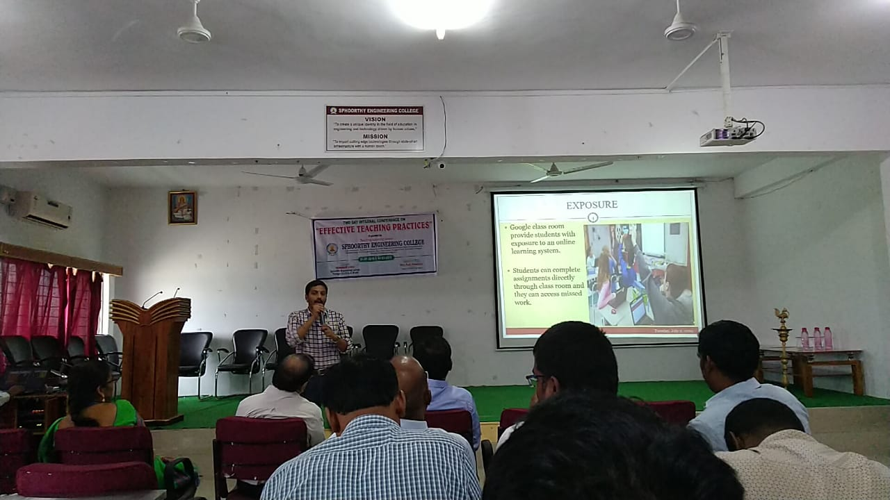

Two-day internal conference on “Effective teaching practices” (01-07-2019 to 02-07-2019)

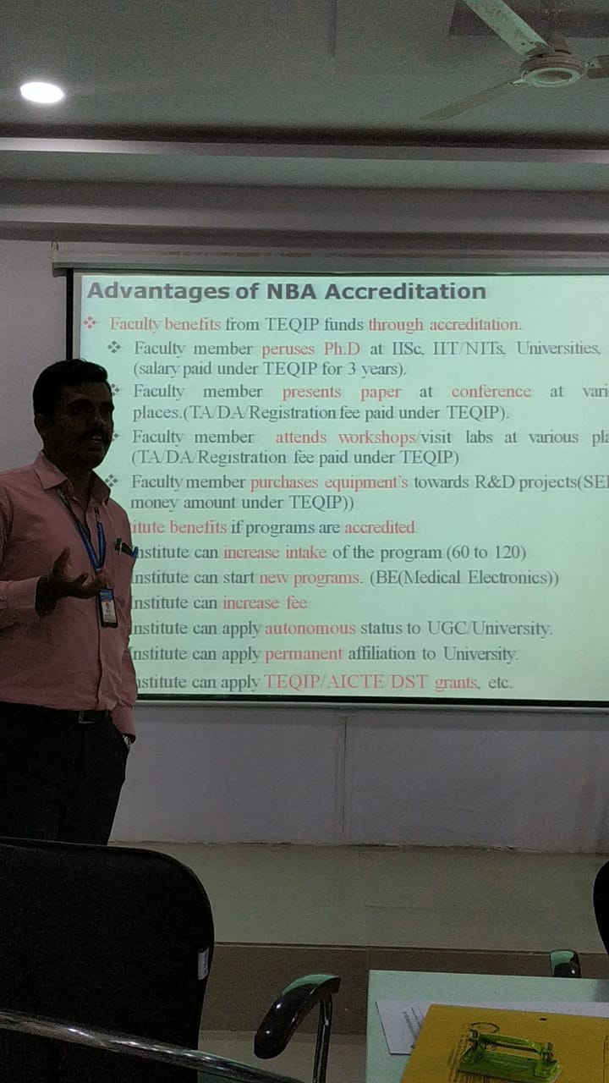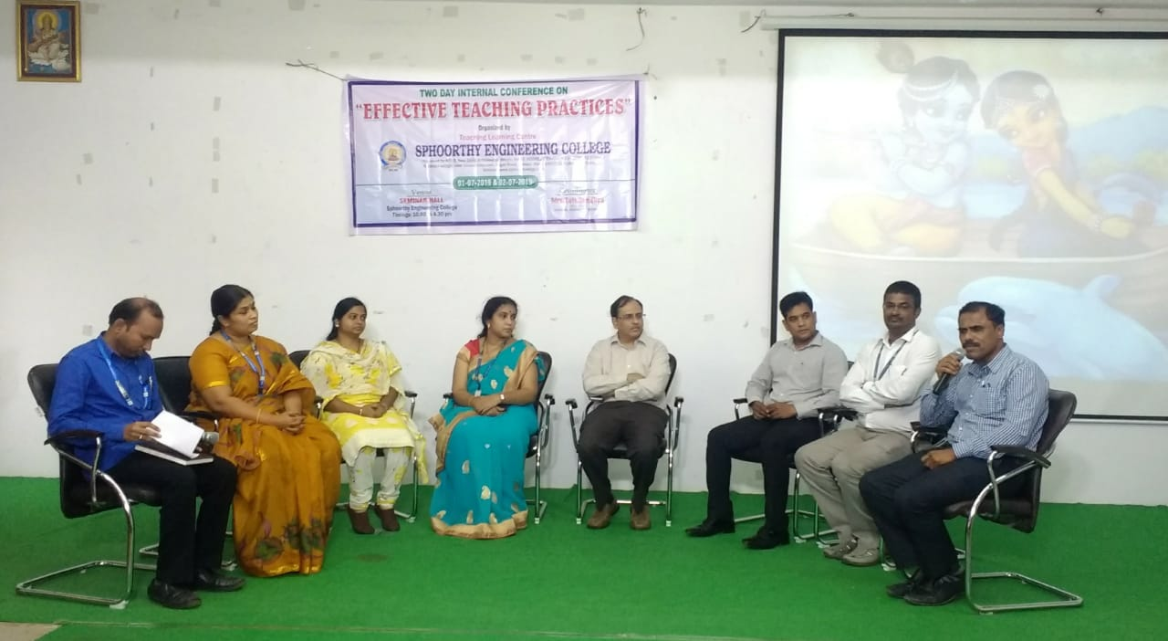

w-

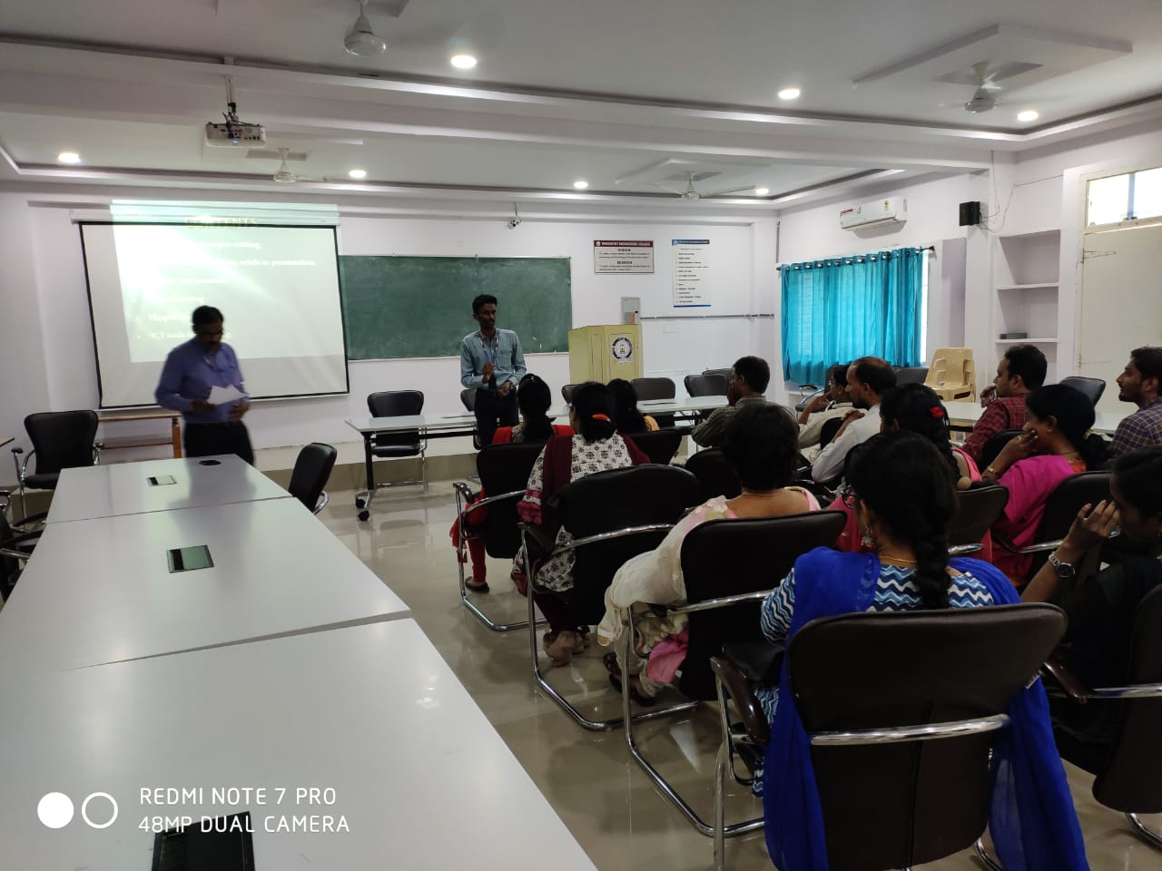

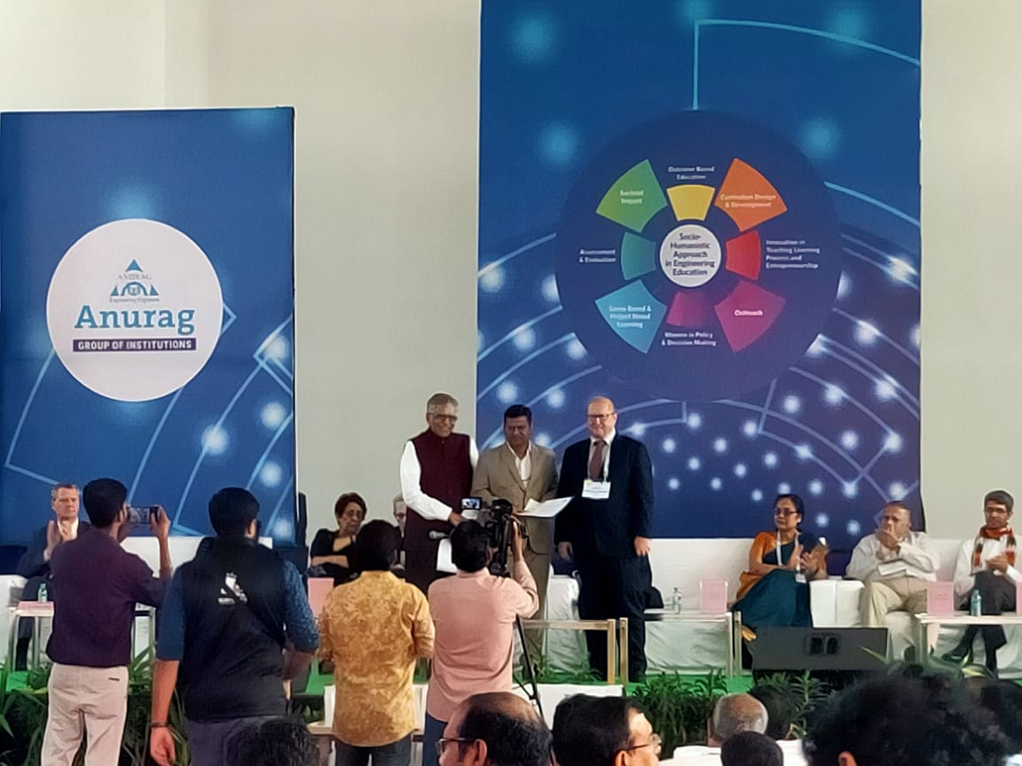

Mr Rammohan rao recieving award for Leadership of TLC at ICTIEE2020

